

* Html and CCS pages

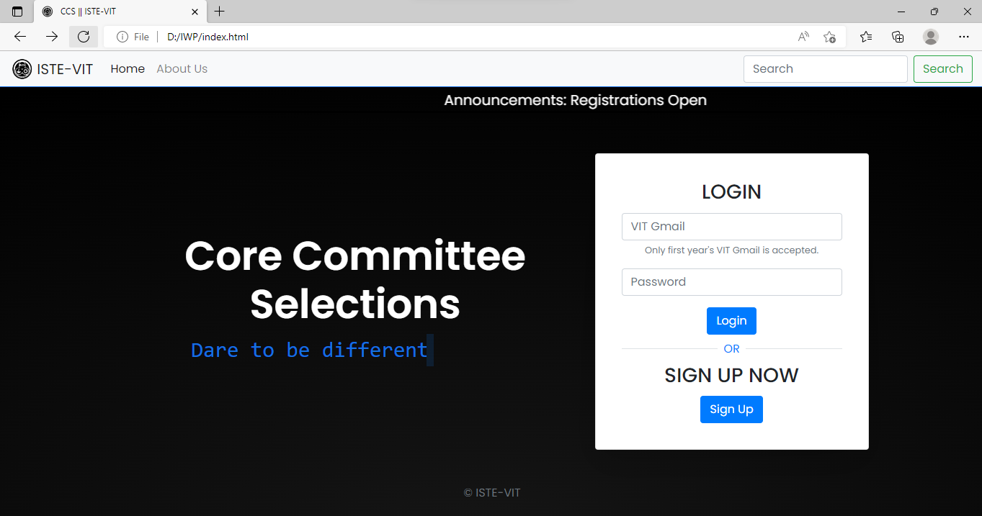

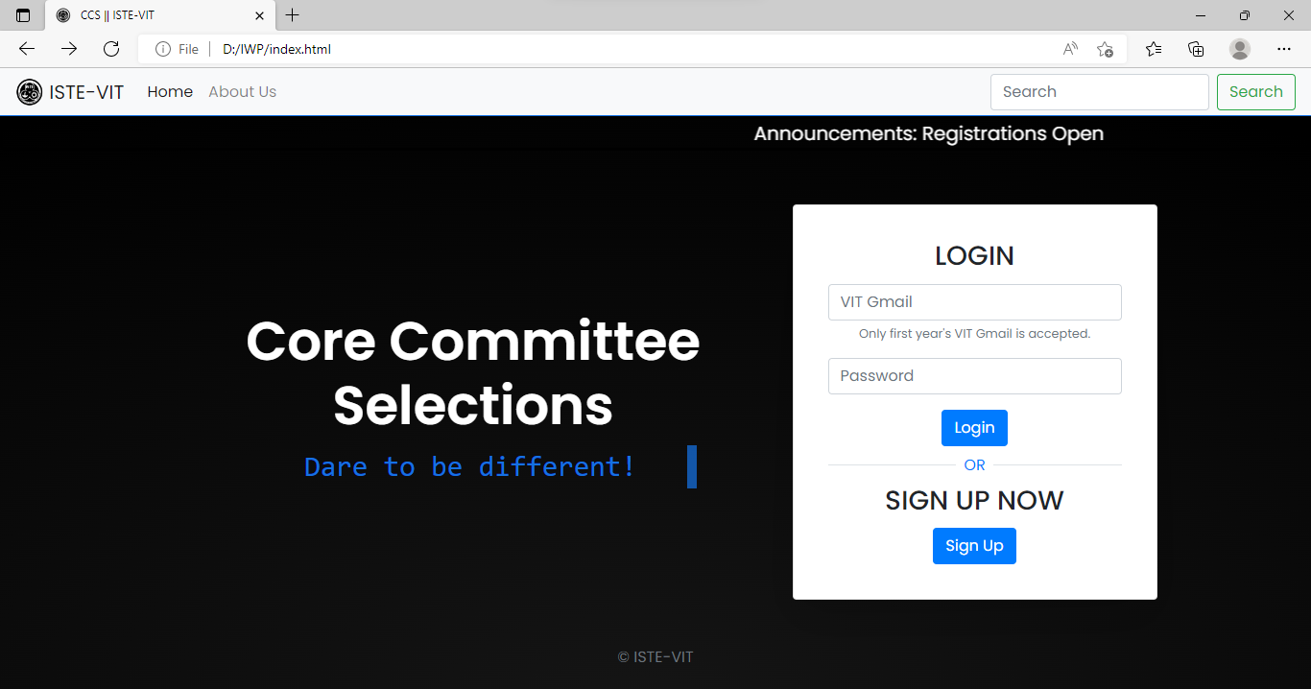

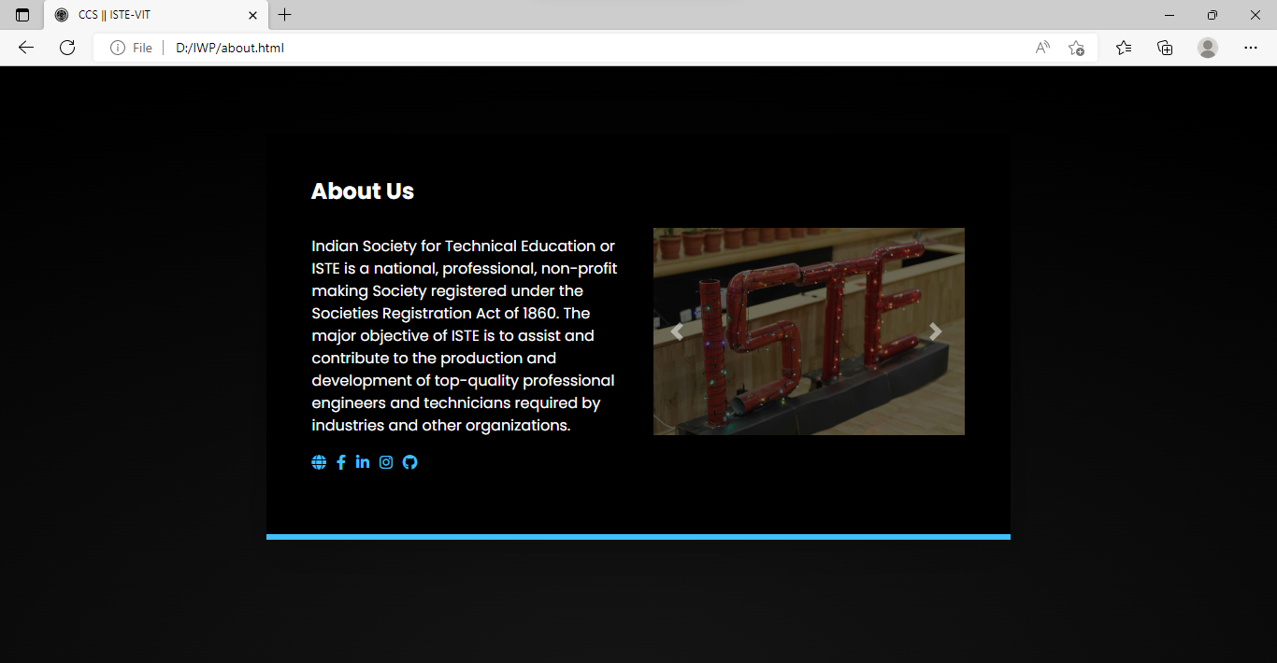

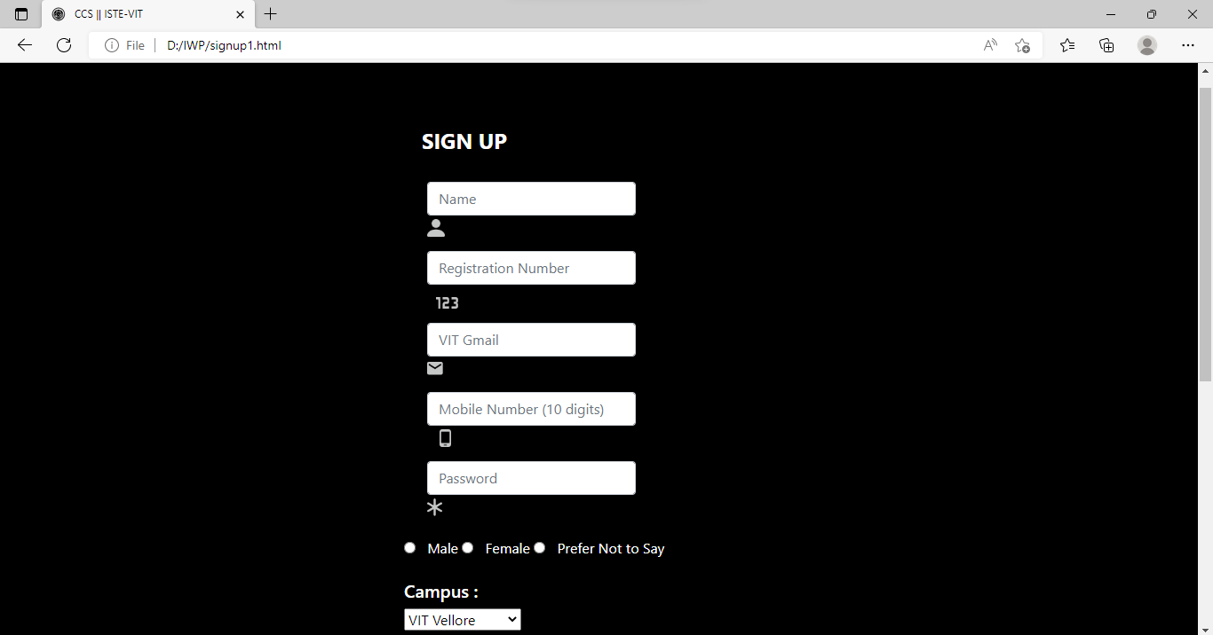

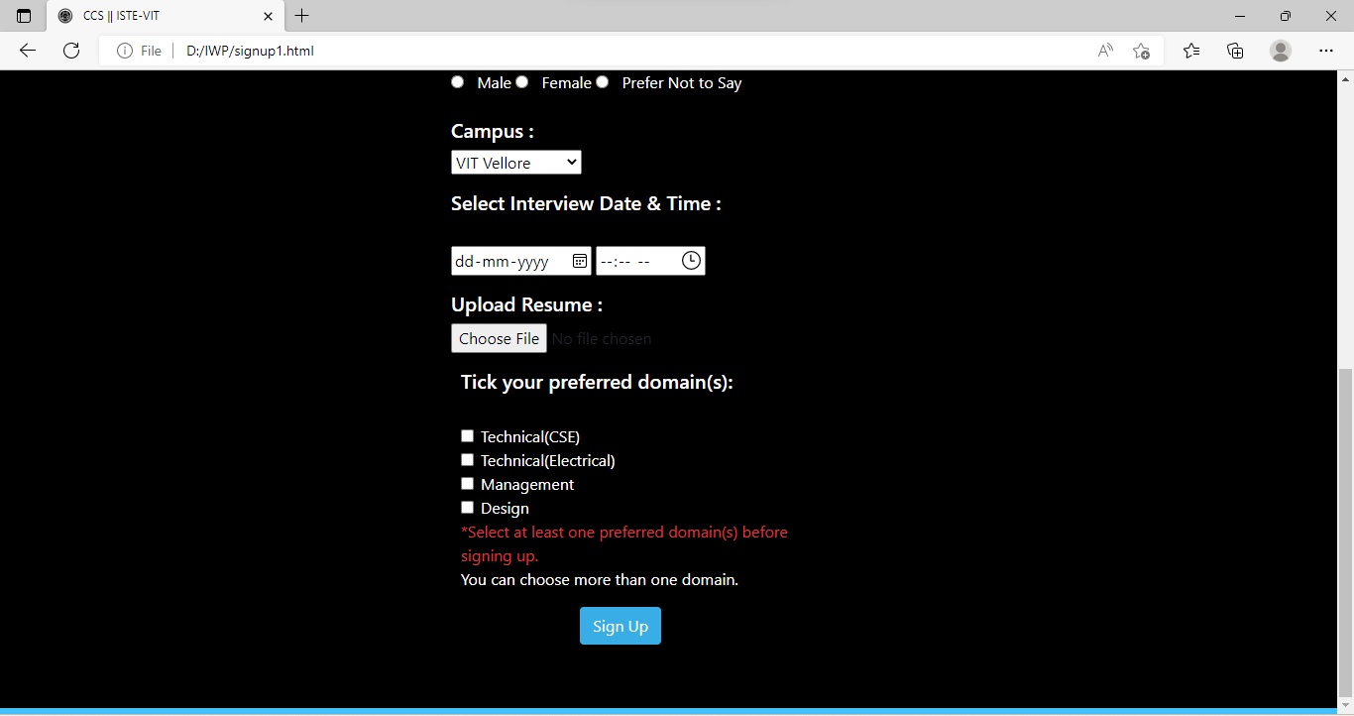

**Index.html:**

<!DOCTYPE html>

<html lang="en" dir="ltr">

<head>

  <meta charset="utf-8">

  <title>CCS || ISTE-VIT</title>

*<!-- link navbar.css -->*

     <link rel="stylesheet" href="D:\IWP\css\navbar.css" />

  <link rel="icon" type="image/png" href="D:\IWP\img\icon\Iste-icon.ico">

  <meta name="viewport" content="width=device-width, initial-scale=1.0">

  <link rel="stylesheet" href="https://cdnjs.cloudflare.com/ajax/libs/font-awesome/4.7.0/css/font-awesome.min.css">

  <link rel="stylesheet" href="D:\IWP\css\style.css" />

  <link rel="preconnect" href="https://fonts.gstatic.com" />

  <link href="https://fonts.googleapis.com/css?family=Roboto" rel="stylesheet" />

  <link rel="stylesheet" href="https://stackpath.bootstrapcdn.com/bootstrap/4.1.3/css/bootstrap.min.css" />

  <link rel="stylesheet" href="D:\IWP\css\ccslogin.css" />

<style>

  #navcustom {

display:block !important;

  }

</style>

</head>

<body >

  <nav >

    <div class="navbar navbar-expand-lg navbar-light bg-light">

    <a class="navbar-brand" href="index.html">

      <img src="D:\IWP\img\icon\Iste-icon.ico" width="30" height="30" class="d-inline-block align-top" alt="">

      ISTE-VIT

    </a>

    <button class="navbar-toggler" type="button" data-toggle="collapse" data-target="#navbarSupportedContent"

      aria-controls="navbarSupportedContent" aria-expanded="false" aria-label="Toggle navigation">

      <span class="navbar-toggler-icon"></span>

    </button>

    <div class="collapse navbar-collapse" id="navbarSupportedContent">

      <ul class="navbar-nav mr-auto">

        <li class="nav-item active">

          <a class="nav-link" href="index.html">Home <span class="sr-only">(current)</span></a>

        </li>

        <li class="nav-item">

          <a class="nav-link" href="about.html">About Us</a>

        </li>

      </ul>

      <form class="form-inline my-2 my-lg-0">

        <input class="form-control mr-sm-2" type="search" placeholder="Search" aria-label="Search">

        <button class="btn btn-outline-success my-2 my-sm-0" type="submit">Search</button>

      </form>

    </div>

  </nav>

  <div id="scroll-container">

    <div id="scroll-text">Announcements: Registrations Open</div>

  </div>

  <header id="header"></header>

  <script>

    $('#header').load('./navbar.html')

  </script>

  <div class="container my-5 text-center">

    <div class="row justify-content-center align-items-center">

      <div class="col-12 col-lg-7 col-md-7 ">

        <h1 class="main-heading">Core Committee Selections</h1>

*<!-- <h3 class="text-primary secondary-heading"> -->*

          <div class="typingEffect6" >

            Dare to be different!

          </div>

*<!-- Dare to be different, dare to be ISTE!*

*</h3> -->*

      </div>

      <div class="col-11 col-lg-4 col-md-5 p-3 mt-2 card shadow-lg login-panel-card">

        <div class="card-body">

          <h3 class="card-title">LOGIN</h3>

            <form class="card-text" id="login-form">

              <div class="form-group">

                <input type="email" pattern=".+2022.*@vitstudent.ac.in$" class="form-control" id="email"

                  placeholder="VIT Gmail">

                <small id="emailHelp" class="form-text text-muted">Only first year's VIT Gmail is accepted.</small>

              </div>

              <div class="form-group">

                <input type="password" minlength="6" required class="form-control" id="password"

                  placeholder="Password" />

              </div>

              <button type="submit" class="btn btn-primary ">Login</button>

              <div class="d-flex align-items-center my-2">

                <div class="flex-grow-1 border-bottom"></div>

                <div class="px-2 text-primary">OR</div>

                <div class="flex-grow-1 border-bottom"></div>

              </div>

            </form>

            <h3 class="card-title">SIGN UP NOW</h5>

              <p class="card-text">

                <button type="button" class="btn btn-primary" onclick='window.location.href="./signup1.html"'>Sign

                  Up</button>

              </p>

        </div>

      </div>

    </div>

  </div>

  <footer class="footer">

    <div class="container">

      <center>

      <span class="text-muted">&copy; ISTE-VIT</span>

    </center>

    </div>

</body>

</html>

<!DOCTYPE html>

<html lang="en" dir="ltr">

<head>

  <meta charset="utf-8">

  <title>CCS || ISTE-VIT</title>

*<!-- link navbar.css -->*

     <link rel="stylesheet" href="D:\IWP\css\navbar.css" />

  <link rel="icon" type="image/png" href="D:\IWP\img\icon\Iste-icon.ico">

  <meta name="viewport" content="width=device-width, initial-scale=1.0">

  <link rel="stylesheet" href="https://cdnjs.cloudflare.com/ajax/libs/font-awesome/4.7.0/css/font-awesome.min.css">

  <link rel="stylesheet" href="D:\IWP\css\style.css" />

  <link rel="preconnect" href="https://fonts.gstatic.com" />

  <link href="https://fonts.googleapis.com/css?family=Roboto" rel="stylesheet" />

  <link rel="stylesheet" href="https://stackpath.bootstrapcdn.com/bootstrap/4.1.3/css/bootstrap.min.css" />

  <link rel="stylesheet" href="D:\IWP\css\ccslogin.css" />

<style>

  #navcustom {

display:block !important;

  }

</style>

</head>

<body >

  <nav >

    <div class="navbar navbar-expand-lg navbar-light bg-light">

    <a class="navbar-brand" href="index.html">

      <img src="D:\IWP\img\icon\Iste-icon.ico" width="30" height="30" class="d-inline-block align-top" alt="">

      ISTE-VIT

    </a>

    <button class="navbar-toggler" type="button" data-toggle="collapse" data-target="#navbarSupportedContent"

      aria-controls="navbarSupportedContent" aria-expanded="false" aria-label="Toggle navigation">

      <span class="navbar-toggler-icon"></span>

    </button>

    <div class="collapse navbar-collapse" id="navbarSupportedContent">

      <ul class="navbar-nav mr-auto">

        <li class="nav-item active">

          <a class="nav-link" href="index.html">Home <span class="sr-only">(current)</span></a>

        </li>

        <li class="nav-item">

          <a class="nav-link" href="about.html">About Us</a>

        </li>

      </ul>

      <form class="form-inline my-2 my-lg-0">

        <input class="form-control mr-sm-2" type="search" placeholder="Search" aria-label="Search">

        <button class="btn btn-outline-success my-2 my-sm-0" type="submit">Search</button>

      </form>

    </div>

  </nav>

  <div id="scroll-container">

    <div id="scroll-text">Announcements: Registrations Open</div>

  </div>

  <header id="header"></header>

  <script>

    $('#header').load('./navbar.html')

  </script>

  <div class="container my-5 text-center">

    <div class="row justify-content-center align-items-center">

      <div class="col-12 col-lg-7 col-md-7 ">

        <h1 class="main-heading">Core Committee Selections</h1>

*<!-- <h3 class="text-primary secondary-heading"> -->*

          <div class="typingEffect6" >

            Dare to be different!

          </div>

*<!-- Dare to be different, dare to be ISTE!*

*</h3> -->*

      </div>

      <div class="col-11 col-lg-4 col-md-5 p-3 mt-2 card shadow-lg login-panel-card">

        <div class="card-body">

          <h3 class="card-title">LOGIN</h3>

            <form class="card-text" id="login-form">

              <div class="form-group">

                <input type="email" pattern=".+2022.*@vitstudent.ac.in$" class="form-control" id="email"

                  placeholder="VIT Gmail">

                <small id="emailHelp" class="form-text text-muted">Only first year's VIT Gmail is accepted.</small>

              </div>

              <div class="form-group">

                <input type="password" minlength="6" required class="form-control" id="password"

                  placeholder="Password" />

              </div>

              <button type="submit" class="btn btn-primary ">Login</button>

              <div class="d-flex align-items-center my-2">

                <div class="flex-grow-1 border-bottom"></div>

                <div class="px-2 text-primary">OR</div>

                <div class="flex-grow-1 border-bottom"></div>

              </div>

            </form>

            <h3 class="card-title">SIGN UP NOW</h5>

              <p class="card-text">

                <button type="button" class="btn btn-primary" onclick='window.location.href="./signup1.html"'>Sign

                  Up</button>

              </p>

        </div>

      </div>

    </div>

  </div>

  <footer class="footer">

    <div class="container">

      <center>

      <span class="text-muted">&copy; ISTE-VIT</span>

    </center>

    </div>

</body>

</html>

**About.html:**

<!DOCTYPE html>

<html lang="en">

  <head>

    <meta charset="utf-8" />

    <title>CCS || ISTE-VIT</title>

    <link rel="icon" type="image/png" href="D:\IWP\img\icon\Iste-icon.ico" />

    <link

      rel="stylesheet"

      href="https://cdnjs.cloudflare.com/ajax/libs/font-awesome/4.7.0/css/font-awesome.min.css"

    />

    <link

      rel="stylesheet"

      href="https://stackpath.bootstrapcdn.com/bootstrap/4.1.3/css/bootstrap.min.css"

      integrity="sha384-MCw98/SFnGE8fJT3GXwEOngsV7Zt27NXFoaoApmYm81iuXoPkFOJwJ8ERdknLPMO"

      crossorigin="anonymous"

    />

    <link

      href="https://fonts.googleapis.com/css?family=Roboto"

      rel="stylesheet"

    />

*<!-- Stylesheet for Font Icons-->*

    <link

      defer

      rel="stylesheet"

      type="text/css"

      href="https://cdnjs.cloudflare.com/ajax/libs/font-awesome/5.13.0/css/all.min.css"

    />

*<!-- Stylesheet for Custon CSS -->*

    <style>

      a {

        margin-right: 2%;

        color: #40c0ff !important;

      }

      @media (max-width: 750px) {

        #smallScreen {

          display: block !important;

        }

        #largeScreen {

          display: none !important;

        }

      }

    </style>

  <link rel="stylesheet" href="D:\IWP\css\style.css" />

  </head>

  <body>

    <header id="header"></header>

    <br />

    <div

      class="container col-11 col-lg-7 col-md-10 col-sm-10 col-xs-7 p-5 mt-lg-5 shadow-lg"

      style="

        background-color: black;

        border-bottom: 6px solid #40c0ff;

        padding-bottom: 10px;

      "

    >

      <h4 style="text-align: left; color: white;"><b>About Us</b></h4>

      <div class="row">

        <div class="text-left col-lg-6 col-md-6 p-3 pt-4">

          <p style="color:white">

            Indian Society for Technical Education or ISTE is a national,

            professional, non-profit making Society registered under the

            Societies Registration Act of 1860. The major objective of ISTE is

            to assist and contribute to the production and development of

            top-quality professional engineers and technicians required by

            industries and other organizations.

          </p>

          <div

            class="column"

            id="largeScreen"

            style="text-align: left; display: block;"

          >

            <a class="social-wb" href="https://istevit.in/">

              <i class="fa fa-globe"></i>

            </a>

            <a class="social-fb" href="https://m.facebook.com/ISTE.VIT/">

              <i class="fab fa-facebook-f"></i>

            </a>

            <a

              class="social-li"

              href="https://www.linkedin.com/company/indian-society-for-technical-education"

            >

              <i class="fab fa-linkedin-in"></i>

            </a>

            <a

              class="social-in"

              href="https://www.instagram.com/iste_vit_vellore/ "

            >

              <i class="fab fa-instagram"></i>

            </a>

            <a class="social-yt" href="https://github.com/ISTE-VIT">

              <i class="fab fa-github"></i>

            </a>

          </div>

        </div>

        <div class="text-center col-lg-6 col-md-6 p-3">

          <div

            id="carouselExampleControls"

            class="carousel slide"

            data-ride="carousel"

          >

            <div class="carousel-inner">

              <div class="carousel-item active">

                <img

                  class="d-block w-100"

                  src="D:\IWP\img\pic5.jpg"

                  alt="First slide"

                />

              </div>

              <div class="carousel-item">

                <img

                  class="d-block w-100"

                  src="D:\IWP\img\pic1.jpg"

                  alt="Second slide"

                />

              </div>

              <div class="carousel-item">

                <img

                  class="d-block w-100"

                  src="D:\IWP\img\pic3.jpg"

                  alt="Third slide"

                />

              </div>

            </div>

            <a

              class="carousel-control-prev"

              href="#carouselExampleControls"

              role="button"

              data-slide="prev"

            >

              <span

                class="carousel-control-prev-icon"

                aria-hidden="true"

              ></span>

              <span class="sr-only">Previous</span>

            </a>

            <a

              class="carousel-control-next"

              href="#carouselExampleControls"

              role="button"

              data-slide="next"

            >

              <span

                class="carousel-control-next-icon"

                aria-hidden="true"

              ></span>

              <span class="sr-only">Next</span>

            </a>

          </div>

        </div>

        <div

          class="column col-lg-6 col-md-6 col-12"

          id="smallScreen"

          style="text-align: center; display: none;"

        >

          <a class="social-wb" href="https://istevit.in/">

            <i class="fa fa-globe"></i>

          </a>

          <a class="social-fb" href="https://m.facebook.com/ISTE.VIT/">

            <i class="fab fa-facebook-f"></i>

          </a>

          <a

            class="social-li"

            href="https://www.linkedin.com/company/indian-society-for-technical-education"

          >

            <i class="fab fa-linkedin-in"></i>

          </a>

          <a

            class="social-in"

            href="https://www.instagram.com/iste_vit_vellore/"

          >

            <i class="fab fa-instagram"></i>

          </a>

          <a class="social-yt" href="https://github.com/ISTE-VIT">

            <i class="fab fa-github"></i>

          </a>

        </div>

      </div>

    </div>

  </body>

</html>

**Style.css:**

@import url('https://fonts.googleapis.com/css2?family=Poppins:ital,wght@0,100;0,200;0,300;0,400;0,500;0,600;0,700;0,800;0,900;1,100;1,200;1,300;1,400;1,500;1,600;1,700;1,800;1,900&display=swap');

body {

  font-family: 'Poppins';

  background: radial-gradient(104.93% 104.93% at 48.51% 102.83%, #151515 0%, #000000 100%);

  background-repeat: no-repeat;

  background-size: cover;

 min-height: 100vh;

}

.signup-head{

  color: white;

 font-size: 3rem;

 font-family: 'Poppins';

font-weight: 600;

padding-left: 10vw;

}

.fg label{

  font-size: 1.4rem;

  font-family: 'Poppins';

  font-style: normal;

  font-weight: 400;

  color: rgb(255, 255, 255);

  margin-right: 20px;

  text-align: right;

}

.form-inp {

   border: none;

   border-bottom: 2px solid #ffffff;

    background: transparent;

    color: white;

    width: 60%;

}

.form-inp:focus {

  outline: none;

}

select, input[type="checkbox"], input[type="radio"] {

*/* -webkit-border-radius:0; */*

  -moz-border-radius:0;

  border-radius:0;

  -webkit-appearance:none;

  outline:none;

}

input[type=checkbox] + label

 {

  position: relative;

  padding: 0rem 0 0 3rem;

  user-select: none;

  color: #fff;

}

@media (max-width: 768px) {

  input[type=checkbox] + label

 {

   margin: 5px 2px;

}

}

.rounded-3 {

  border-radius: 25px;

  background: transparent !important;

  color: white !important;

  border: 1px solid #1571E3 !important;

  padding: 5px 25px;

  margin-right: 20px;

}

.rounded-3:hover {

  background: #1571E3 !important;

  color: rgb(255, 255, 255) !important;

  border: 1px solid #1571E3 !important;

}

@media (max-width: 768px) {

  .form-inp {

    width: 100%;

  }

  .signup-head{

    font-size: 2rem;

  }

  .fg label{

    font-size: 1.2rem;

  }

}

.inst-container {

  color: #fff;

}

.inst-container ul li {

  margin-bottom: 10px;

  font-size: 1.1rem;

}

.hero-login {

  float: right;

  padding: 0px 100px;

  animation-name: hero-float2;

  animation-duration: 4s;

  animation-iteration-count: infinite;

}

@keyframes *hero-float2* {

  0% {

    transform: translatey(0px);

  }

  50% {

    transform: translatey(-20px);

  }

  100% {

    transform: translatey(0px);

  }

}

.hero-login img {

  height: 20rem;

  border-radius: 50%;

  margin-top: -160px;

  padding-right: 40px;

  overflow-y: hidden;

}

.verti-dash {

   height: 200px;

   width: 2px;

  padding: 10px 0px;

   border-right: 1px solid #545454;

    margin-right: 20px;

}

@media screen and (max-width: 768px) {

  .hero-login {

    float: none;

    padding: 0px 65px;

  }

  .hero-login img {

    height: 15rem;

    border-radius: 50%;

    margin-top: auto;

    padding-right: 40px;

    overflow-y: hidden;

    margin-left: 70px;

  }

}

.hero-sign {

  float: right;

  padding: 0px 100px;

  animation-name: hero-float2;

  animation-duration: 4s;

  animation-iteration-count: infinite;

}

.hero-sign img {

  height: 20rem;

  border-radius: 50%;

  margin-top: -460px;

  overflow-y: hidden;

}

@media screen and (max-width: 980px) {

  .hero-sign {

    float: none;

    padding: 0px 65px;

  }

  .hero-sign img {

    height: 15rem;

    border-radius: 50%;

    margin-top: auto;

    overflow-y: hidden;

  }

}

.hero-inst {

  float: right;

  padding: 0px 100px;

  animation-name: hero-float2;

  animation-duration: 4s;

  animation-iteration-count: infinite;

}

.hero-inst img {

  height: 20rem;

  border-radius: 50%;

  margin-top: -460px;

  margin-right: -90px;

  overflow-y: hidden;

}

@media screen and (max-width: 980px) {

  .hero-inst {

    float: none;

    padding: 0px 65px;

  }

  .hero-inst img {

    height: 15rem;

    border-radius: 50%;

    margin-top: auto;

    margin-right: auto;

    overflow-y: hidden;

  }

}

.und {

  border-bottom: #1571E3 solid 8px;

}

#scroll-container {

  color:#fff;

  font-size: 20px;

  border: 3px solid black;

  border-radius: 5px;

  overflow: hidden;

}

#scroll-text {

*/* animation properties */*

  -moz-transform: translateX(100%);

  -webkit-transform: translateX(100%);

  transform: translateX(100%);

  -moz-animation: my-animation 15s linear infinite;

  -webkit-animation: my-animation 15s linear infinite;

  animation: my-animation 15s linear infinite;

}

*/* for Chrome */*

@-webkit-keyframes *my-animation* {

  from { -webkit-transform: translateX(100%); }

  to { -webkit-transform: translateX(-100%); }

}

@keyframes *my-animation* {

  from {

    -moz-transform: translateX(100%);

    -webkit-transform: translateX(100%);

    transform: translateX(100%);

  }

  to {

    -moz-transform: translateX(-100%);

    -webkit-transform: translateX(-100%);

    transform: translateX(-100%);

  }

}

.typingEffect6 {

  padding-left: 90px;

  border-right: solid 10px #1571E3;

  white-space: nowrap;

  overflow: hidden;

  font-family: "Source Code Pro", monospace;

  font-size: 30px;

  color: #1571E3;

}

*/* Animation */*

.typingEffect6 {

  animation: animated-text-effect 4s linear 1s 1 normal both,

    animated-cursor 600ms linear infinite;

}

*/* text animation */*

@keyframes *animated-text-effect* {

  from {

    width: 0;

  }

  to {

    width: 550px;

  }

}

*/* cursor animations */*

@keyframes *animated-cursor* {

  from {

    border-right-color: #1571E3;

  }

  to {

    border-right-color: transparent;

  }

}